

Patuakhali Science and Technology University
Faculty of Computer Science and Engineering
CCE 322 :: Computer Peripheral and Interfacing Sessional

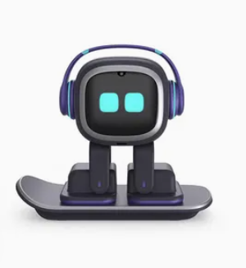
Project Title: EMO Robot

Submitted To-  - Dr. Md Samsuzzaman  Professor  Dept. of Computer and Communication Engineering  - Sarna Majumder  Associate Professor  Dept. of Computer and Communication Engineering | Submitted By-  - 2102022 - Noshin Nazia  - 2102041 - Omar Faruk Tanvir  - 2102062 - Mahajabin Afroz Moushe  - 2002014 - Sanjana Tasnim Prome  - 2002022 - Arup Ghosh

Submission Date: 17th June, 2026

Table of Contents
Emo Robot 3
1. Introduction 3
2. Objectives 3
3. Problem Statement 3
4. Scope 3
5. Methodology 4
5.1 System Architecture 4
5.2 Technology Stack 4
6.Costing Estimation: 5
7.Gantt Chart 6
8.Visual Models 6
9. Future Plans 7
10. Advantages 7
11. Limitations 8
12. Conclusion 8
13. References…………………………………………………………………………………………8

Emo Robot

1. Introduction
The Emo robot is an emotion detector robot that can detect people’s feelings. We used a raspberry Pi 3 to create the project model. In this project we used a camera to capture human facial expressions and detect emotions. After detecting the emotion, the robot responds in many ways like it changes LED colors on screen, shows emotion related text or emoji on an OLED display, moves hands using servo motors and produce sound through a mini speaker.
The main goal of this project is to build a smart robot that can interact with humans in a more natural and expressive way.

2. Objectives
- To detect human emotions using a camera
- To show different LED colors for different emotions
- To display detected emotions on an OLED display
- To control the robot’s hands using servo motors
- To produce sound on emotions

3. Problem Statement
People’s feelings are a part of how we talk to each other. We can usually tell how someone is feeling by looking at their face. Machine and robots cannot do this.
In this project we aim to solve this problem by designing a robot that can recognize emotions and respond visually, physically and through sound.

4. Scope
The Emo robot project can be useful in many areas, including -
- Science fairs
- Exhibition
- Teaching in classroom
- Human-machine interaction research
- Robotics
- Research on how people and machines talk to each other.
- In old-age homes to be a companion if it can talk.

5. Methodology
We made the Emo robot by combining a few techniques and components. First the camera takes a picture of the person’s face in real-time event. Then the Raspberry Pi 3 detects the picture of that person and detect the emotion that the person is feeling at that time. After that the robot does a thing based on how the person is feeling.

5.1 System Architecture
- The camera takes a picture of the persons face
- The Raspberry Pi 3 is the brain of the Emo robot
- The RGB LED shows how the person is feeling using colors
- The OLED Display Displays text or emoji (person’s feeling)
- The Servo Motors makes the hand movement of robot
- The Mini Speaker makes sound
- The Power Supply give the required power

Workflow:
Face Capture → Emotion Detection → Processing → Output Activation → Robot Response

5.2 Technology Stack
The parts we used to make the Emo robot are:
Hardware
- Raspberry Pi 3
- Pi Camera 5MP
- SG90 Servo Motors
- RGB LED
- 0.96" OLED Display
- Mini Speaker
- Breadboard
- Jumper Wires
- Resistors

Software / Libraries
- Python 3
- OpenCV
- DeepFace
- gpiozero
- luma.oled
- pygame

Programming Tool
VS Code for write the code

Costing Estimation:
Component | Price (৳)
Raspberry Pi 400 4GB RAM | 11,300
Transcend 16GB UHS-I U1 MicroSD Memory Card | 650
Raspberry Pi 4 Power Supply 5V 3A USB Type C | 790
Servo Motor Micro SG90 180 Degree Rotation (2 pcs) | 130*2
RGB Full Color LED SMD Module | 55
220 Ohm 1/4W Resistors | 10
0.96" Inch I2C OLED Display White | 350
Breadboard Full Size Bare 830 Tie Points | 145
Male to Female Jumper Wires 40 Pin 30cm | 150
Raspberry Pi Camera 5MP | 740
PCB Mount Mini Speaker 8 Ohm 0.2W | 120
Others | 500-1000
Total Cost | 15,000-15,500/-

Components from: RoboticsBd (https://store.roboticsbd.com/)

7. Gantt Chart
Task | Month 1 | Month 2 | Month 3 | Month 4
Structural Design | ✓
Circuit Assembly | ✓ | ✓
Sensor & Display Integration |  | ✓ | ✓
Emotion Coding |  |  | ✓ | ✓
Final Assembly & Testing |  |  |  | ✓

Visual Models

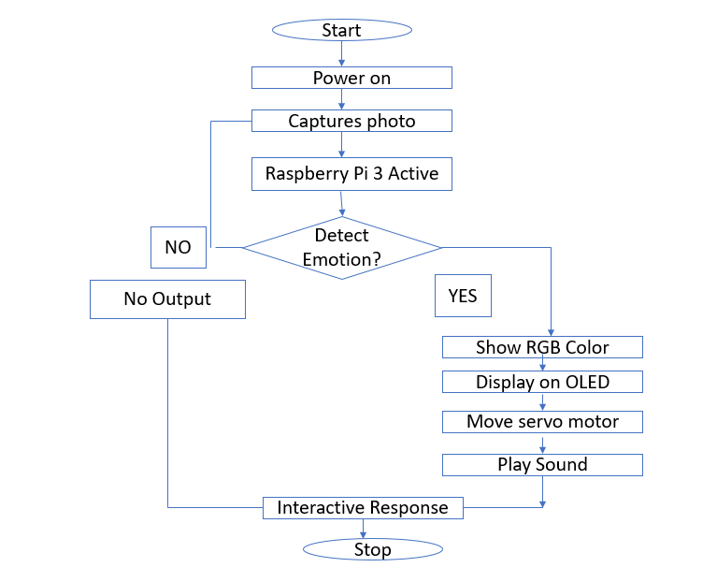
Fig: Flow Chart of Emo Robot
Block Diagram
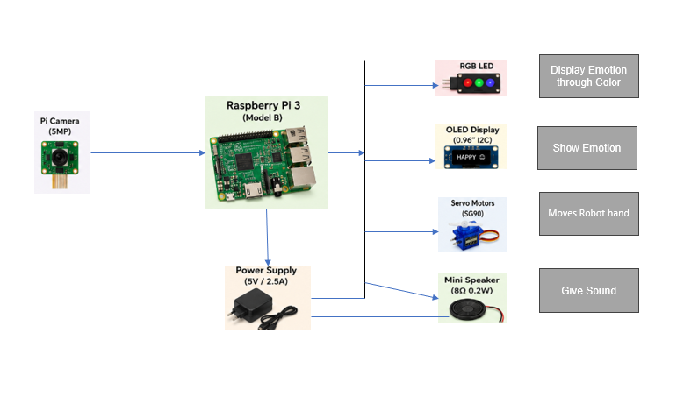
Fig: Block Diagram of Emo Robot

9. Future Plans
We can integrate the following features in future -
- Add more feelings like fear, tension, surprise, annoyance etc.
- Teach the robot to recognize gestures
- Make the robot respond to people with voice integration.
- Add mobile app control via wireless network.
- Improve accuracy for emotion detection.

10. Advantages
- Interactive robotic behavior
- Easy to understand
- Adjust AI and robotics
- Real time emotion detection

11. Limitations
The Emo robot is not perfect -
- It can’t show how people are feeling if the light integration is bad.
- If the camera is not good the Emo robot does not work well.
- The Emo Robot can only tell feelings.
- The Emo Robot needs a good brain to work.

12. Conclusion
The Emo Robot project shows that a robot can tell how people are feeling and respond in a way that makes sense. With some problems the Emo Robot works well and can talk to people in a more natural way. It is an example of how robots can be used to help people.
13. References
[1] L. Zhang, M. Jiang, D. Farid, and A. Hossain, “Intelligent facial emotion recognition and semantic-based topic detection for a humanoid robot,” Expert Systems with Applications, vol. 40, no. 13, pp. 5160–5168, 2013.
[2] M. Spezialetti, G. Placidi, and S. Rossi, “Emotion recognition for human-robot interaction: Recent advances and future perspectives,” Frontiers in Robotics and AI, vol. 7, Art. no. 532279, 2020.
[3] A. Author et al., “Multi-face Emotion Detection for Effective Human-Robot Interaction,” arXiv preprint, arXiv:2501.07213, Jan. 2025.
[4] [3] R. Raj, “An Improved Facial Emotion Recognition System Using Deep Learning,” Scientific Reports, vol. 15, 2025.
[5] M. T. A. Tashrif, J. M. A. Khan, S. H. Mahir, and M. S. Uddin, “Emotion recognition from Bangla dialect speech using privacy-aware deep learning models: A comparative analysis,” International Journal of Speech Technology, vol. 29, pp. 41–58, 2026.

